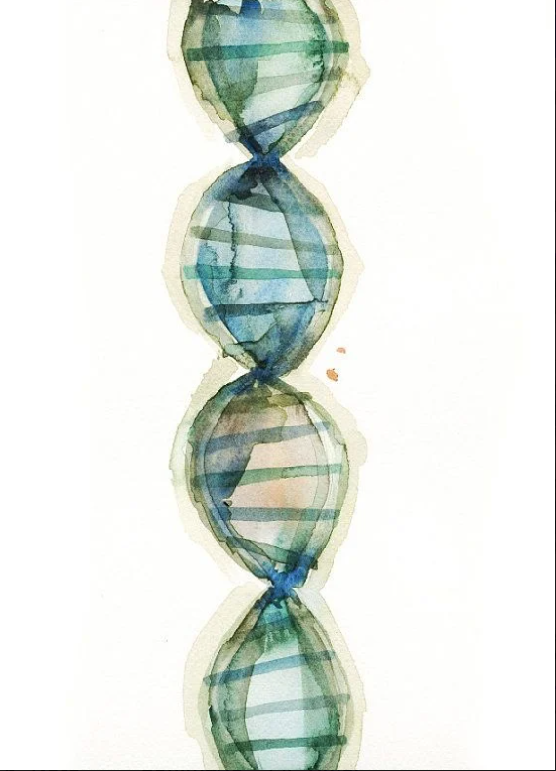

PhD program in Medical Biotechnologies
(Coordinator Prof. Francesco Iannelli)

School of Specialization in Pathological Anatomy
(Coordinator Prof. Cristiana Bellan)

Seminar notice

Prof. Reiner Seibert

Institute of Human Genetics, University Hospital of Ulm, Ulm Germany

DNA Methylation profiling of malignant lymphomas: between biology and classification
Siena, 24 February 2026, 12.00 – 13.00 a.m.

Aula 10, Centro Didattico Policlinico “Le Scotte”
Google meet: meet.google.com/vmm-eeid-bna

